**Practical no. 5**

**FS19CO042**

**Aim:** Using Stream API implement following programs.

* + 5.1 Write a generic method to count the number of elements in a collection that have a specific property (for example, odd integers, prime numbers, palindromes).
  + 5.2 Write a method which takes a list of words as an argument, groups the words by their lengths and returns the groupings in the form of Map>. (The keys in the map are the lengths and the values are the lists of words of that length.)
  + 5.3 Given a List<List> write a program to convert it into a List. (Hint: Use flatMap method in Stream interface)
  + 5.4 Given: class Album{ public final String name; public final int yearOfRelease; public final List tracks; }   
     class Track{ public final int rating; }   
    a) Write a method which takes a list of albums as an argument and returns a list of names of all albums sorted by the year of release.   
    b) Write a method which takes a list of albums as an argument and returns a list of names of all albums containing at least one track having rating more than four. The returned list should be sorted by the year of release.

**Tool used:** Editor (Notepad/Intellij IDE), JDK and JRE

**Code:**

* **5.1 Write a generic method to count the number of elements in a collection that have a specific property (for example, odd integers, prime numbers, palindromes).**

import java.util.Arrays;

import java.util.List;

import java.util.stream.Stream;

public class exp5_1 {

static class Student {

String name = "";

public int roll = 0;

public int marks = 0;

public Student(String name, int roll, int marks) {

this.name = name;

this.roll = roll;

this.marks = marks;

}

}

public static <T extends Number> long evenNumbers(List<T> list) {

Stream<T> stream = list.stream();

return stream.filter(number -> number.doubleValue() % 2 != 0).count();

}

public static <T extends Student> long numberOfPassedStudents(List<? extends Student> list) {

Stream<T> stream = (Stream<T>) list.stream();

return stream.filter(student -> student.marks >= 35).count();

}

public static void main(String[] args) {

Student s1 = new Student("Roy", 43, 60);

Student s2 = new Student("Niel", 44, 49);

Student s3 = new Student("Leo", 30, 75);

Student s4 = new Student("lisa", 35, 30);

Student s5 = new Student("Russ", 40, 28);

List<Integer> list = Arrays.asList(1, 2, 3, 4, 5, 6, 7, 8, 9, 10);

List<Student> list1 = Arrays.asList(s1, s2, s3, s4, s5);

long evenNumbers = evenNumbers(list) ;

long numberOfPassedStudents = numberOfPassedStudents(list1) ;

System.out.println("There are "+ evenNumbers +" even numbers.");

System.out.println(numberOfPassedStudents+" students have passed the exam.");

}

}

Output:

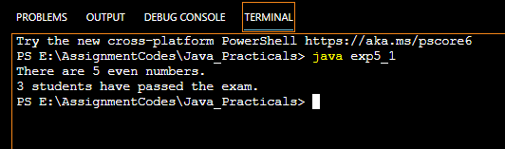

* **5.2 Write a method which takes a list of words as an argument, groups the words by their lengths and returns the groupings in the form of Map>. (The keys in the map are the lengths and the values are the lists of words of that length.)**

import java.util.*;

import java.util.stream.Collectors;

import java.util.stream.Stream;

// main class and method

public class exp5_2{

// main Driver

private static Stream<String> stream;

public static void main(String[] args)

{

// create a list

List<String> strings = Arrays.asList("this", "is", "a", "long", "list", "of",

"strings", "to", "use", "as", "a", "trial");

stream = strings.stream();

Map<Integer, List<String>> lengthMap = stream.collect(Collectors.groupingBy(String::length));

lengthMap.forEach((k,v) -> System.out.printf("%d: %s%n", k, v));

}

}

Output:



* **5.3 Given a List<List> write a program to convert it into a List. (Hint: Use flatMap method in Stream interface)**

import java.util.*;

import java.util.stream.*;

class exp5_3 {

public static void main(String[] args) {

ArrayList<String> list1 = new ArrayList();

list1.add("Government");

list1.add("Polytechnic");

list1.add("Mumbai");

ArrayList<String> list2 = new ArrayList();

list2.add("A.Y. Jung Marg");

list2.add("Kherwadi");

list2.add("Bandra (E)");

ArrayList<ArrayList<String>> listOflist = new ArrayList();

listOflist.add(list1);

listOflist.add(list2);

System.out.println("LIST1 : " + list1);

System.out.println("LIST2 : " + list2);

System.out.println("LIST<LIST<String>> :" + listOflist);

ArrayList<String> result = new ArrayList();

listOflist.forEach(result::addAll);

System.out.println("RESULT : " + result);

}

} 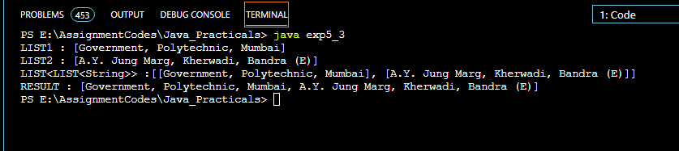

* **5.4 Given: class Album{ public final String name; public final int yearOfRelease; public final List tracks;   
   class Track{ public final int rating; }   
  a) Write a method which takes a list of albums as an argument and returns a list of names of all albums sorted by the year of release.   
    
  b) Write a method which takes a list of albums as an argument and returns a list of names of all albums containing at least one track having rating more than four. The returned list should be sorted by the year of release.**

import java.util.*;

import java.util.stream.*;

public class exp5_4{

static class Track{

public final String name;

public final int rating;

public Track(String name, int rating){

this.name = name;

this.rating = rating;

}

public String toString(){

return this.name + " (" + this.rating + ") ";

}

}

static class Album{

public final String name;

private final List<Track> tracks;

private int yearOfRelease;

public int getYear(){

return yearOfRelease;

}

public List<Track> getTracks(){

return tracks;

}

public int maxRating(){

Track maxTrack = tracks.stream().reduce(new Track("temp",0), (maxTrackYet, currTrack) -> {

if(maxTrackYet.rating < currTrack.rating)

return currTrack;

return maxTrackYet;

});

return maxTrack.rating;

}

public Album(String name, List<Track> trackList, int yearOfRelease){

this.name = name;

this.yearOfRelease = yearOfRelease;

this.tracks = trackList;

}

public String toString(){

return this.name+" ("+this.yearOfRelease+") ";

}

}

static List<String> sortAlbumsByYear(List<Album> albums){

Stream albumStream = albums.stream();

Object sorted[] = albumStream.sorted(Comparator.comparingInt(Album::getYear)).toArray();

List<String> sortedList = new ArrayList<>();

for(Object obj : sorted)

sortedList.add(String.valueOf(obj));

return sortedList;

}

static public List<String> filterGoodAlbums(List<Album> albums){

List<String> goodAlbums = new ArrayList<>();

albums.stream().forEach(album -> {

if(album.maxRating() >4)

goodAlbums.add(album.toString());

});

return goodAlbums;

}

public static void main(String[] args) {

System.out.println();

// Preparing albums and tracks

String[] travelNames = {"Ve maahi", "Duniya", "Bolna", "Kabira", "Vaaste"};

int[] travelRatings= {5,6,4,8,5};

List<Track> travelSongs = new ArrayList<>();

for(int i=0; i<travelNames.length; i++)

travelSongs.add(new Track(travelNames[i], travelRatings[i]));

Album travelAlbum = new Album("Travel",travelSongs, 2009);

String[] rapNames = {"Mirchi", "ChalBombay", "Kohinoor"};

int[] rapRatings = {1, 3,2};

List<Track> rapSongs = new ArrayList<>();

for(int i=0; i<rapNames.length; i++)

rapSongs.add(new Track(rapNames[i], rapRatings[i]));

Album rapAlbum = new Album("Rap",rapSongs, 2006);

String[] hipHopNames = {"Ve maahi", "Duniya", "Bolna", "Kabira", "Vaaste"};

int[] hiphopRatings = {5,9,9,4,7};

List<Track> hipHopSongs = new ArrayList<>();

for(int i=0; i<hipHopNames.length; i++)

hipHopSongs.add(new Track(hipHopNames[i], hiphopRatings[i]));

Album hipHopAlbum = new Album("Hip hop",hipHopSongs, 2017);

String[] jazzNames = {"Sham", "Masakali","Lovely"};

int[] jazzRatings = {3,1,2};

List<Track> jazzSongs = new ArrayList<>();

for(int i=0; i<jazzNames.length; i++)

jazzSongs.add(new Track(jazzNames[i], jazzRatings[i]));

Album jazzAlbum = new Album("Jazz",jazzSongs, 1995);

List<String> sortedAlbums = sortAlbumsByYear(Arrays.asList(travelAlbum, jazzAlbum, hipHopAlbum, rapAlbum));

System.out.println("Sorted list of albums by their year of release: \n"+sortedAlbums+"\n");

List<String> goodAlbums = filterGoodAlbums(Arrays.asList(travelAlbum, jazzAlbum, hipHopAlbum, rapAlbum));

System.out.println("Sorted list of Good albums(rating>4) by their year of release: \n"+goodAlbums);

}

}

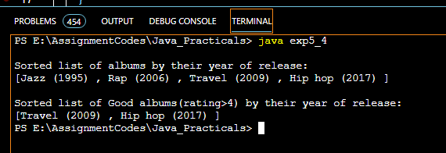

**Conclusion: In this experiment, we used various methods of Java Stream API and performed various programs.**